**COMPONENTS OF COMPUTER**

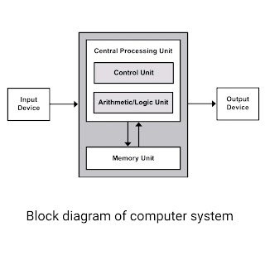

* **Input Unit**

The input unit consists of input devices that are attached to the computer. These devices take input and convert it into binary language that the computer understands. Some of the common input devices are keyboard, mouse, joystick, scanner etc.

* **Central Processing Unit (CPU)**

Once the information is entered into the computer by the input device, the processor processes it. The CPU is called the brain of the computer because it is the control center of the computer.

It first fetches instructions from memory and then interprets them so as to know what is to be done. If required, data is fetched from memory or input device. Thereafter CPU executes or performs the required computation and then either stores the output or displays on the output device.

The CPU has three main components which are responsible for different functions – Arithmetic Logic Unit (ALU), Control Unit (CU) and Memory registers

* **Arithmetic and Logic Unit (ALU)**

The ALU, as its name suggests performs mathematical calculations and takes logical decisions. Arithmetic calculations include addition, subtraction, multiplication and division. Logical decisions involve comparison of two data items to see which one is larger or smaller or equal.

* **Control Unit**

The Control unit coordinates and controls the data flow in and out of CPU and also controls all the operations of ALU, memory registers and also input/output units. It is also responsible for carrying out all the instructions stored in the program. It decodes the fetched instruction, interprets it and sends control signals to input/output devices until the required operation is done properly by ALU and memory

* **Memory Registers**

A register is a temporary unit of memory in the CPU. These are used to store the data which is directly used by the processor. Registers can be of different sizes(16 bit, 32 bit, 64 bit and so on) and each register inside the CPU has a specific function like storing data, storing an instruction, storing address of a location in memory etc.

The user registers can be used by an assembly language programmer for storing operands, intermediate results etc. Accumulator (ACC) is the main register in the ALU and contains one of the operands of an operation to be performed in the ALU.

* **Memory**

 Memory attached to the CPU is used for storage of data and instructions and is called internal memory .The internal memory is divided into many storage locations, each of which can store data or instructions. Each memory location is of the same size and has an address. With the help of the address, the computer can read any memory location easily without having to search the entire memory. when a program is executed, it’s data is copied to the internal memory and is stored in the memory till the end of the execution. The internal memory is also called the Primary memory or Main memory. This memory is also called as RAM, i.e. Random Access Memory. The time of access of data is independent of its location in memory, therefore this memory is also called Random Access memory (RAM).

* **Output Unit**

The output unit consists of output devices that are attached with the computer. It converts the binary data coming from CPU to human understandable form. The common output devices are monitor, printer, plotter etc.